Viking saga

Design document 2023

Rickard Skeppström

## **Godot implement font**

Viking fonts are to unreadable so we are keeping the godot default font for now

https://docs.godotengine.org/en/latest/tutorials/ui/gui_using_fonts.html

How to implement the new viking font to the UI in godot 4

using the viking font for readability

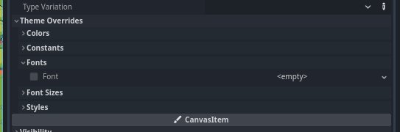

## **Currency**

Gold

## **Healing**

Characters without a major wound naturally heal 1 hit point per day.  
Characters heal up to 3 HP each week

## **Raiding party recovery**

Raiding party should be able to recover some of the soldiers lost in battle, maybe in the form of soldiers flagged as wounded and the at intervals the soldiers either recover or die.

## **Hunger / Thirst**

Hunger and thirst is something that should increase from 0 to a maximum of 1500.  
Increase at a rate of 100 per hour of ingame time  
Threshold 1200 should give some kind of penalty

the feature should impact worldmap movement and army status aswell as playstate stats when fighting.

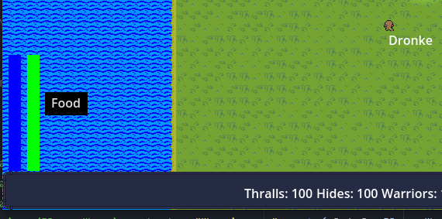

Current implementation:

increases on the worldmap with 1 for every movement made and to recover it you are able to use a button for forage that recovers a random number of thirst and hunger points.

## **Skills**

Fitness  
Lore  
Persuasion  
Taming  
Quickhand  
Stealth  
Awareness  
Short blade  
Long blade  
Bow  
Bludgeon  
Short axe  
Long axe  
Poleblade  
Pole  
Shield  
Leather armour  
Chained armour  
Scaled armour  
Plated armour  
Rune magic

## **Skills groups**

Weapon  
Armour  
Magic  
Misc

## SFX and Music

The sound effects and music should have a viking era feeling to them.

## Runestones

The rune stones of the Viking period were erected in memory of the dead – mostly powerful people – and their honourable deeds. They were intended to be visible and were painted in bright colours. The stones often stood near roads or bridges, where many people passed by. They were not necessarily placed at the burial of the person they commemorated.

The rune stones bring us very close to the Vikings. Their inscriptions feature the names of the people who lived and died at this time. They also provide information about the travels, great achievements and sad fates of these individuals.

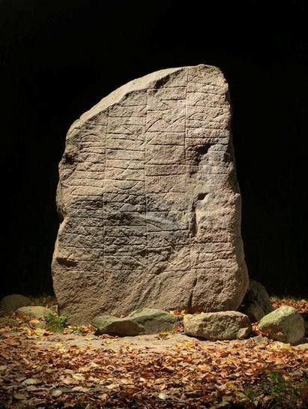The Glavendrup stone. It was raised by Ragnhild and her sons.

## Rune stones in Scandinavia

Rune stones are by and large only found in Scandinavia. Around 250 rune stones are known from Viking Age Denmark. Most of the Scandinavian examples are from Sweden, where there are over 3000 inscriptions.

The tradition apparently only became widespread in Denmark after Harald Bluetooth erected the large Jelling Stone for his father, Gorm the Old, and his mother, Thyra, around 970. Most of the rune stones in Denmark were raised in the period c. 975-1025.

X raised this stone for Y  
The runic inscriptions always name the people who erected the stones and those the stones were raised for. Rune stones were placed in honour of both men and women. Often mentioned are the deceased’s closest kin, position in society, perhaps a short description of his or her character and the circumstances surrounding death. The inscription can also include the rune carver’s name and a curse upon anyone who dares to desecrate the stone. In addition, after the introduction of Christianity, a prayer for the soul of the deceased might be present. Ornamentation and images are also found upon rune stones.

The Rimsø stone. Raised by Thorir in memory of his mother.

The tradition of erecting rune stones was typically associated with the rich and powerful families of the Viking Age, but was not their exclusive preserve. For example, the Hørning stone, found close to Aarhus, displays an inscription stating that it was erected by an emancipated slave.

Stones that were raised by rich women, often commemorated their husbands. Ragnhild was one such woman. Along with her sons, she erected the rune stone at Glavendrup on Funen. Ragnhildr placed this stone in memory of Alli the Pale, priest of the sanctuary, honourable þegn of the retinue. Alli's sons made this monument in memory of their father, and his wife in memory of her husband. And Sóti carved these runes in memory of his lord…

Many rune stones were erected for Viking warriors. A rune stone from Aarhus is a good example of this. Gunnulfr and Eygautr/Auðgautr and Áslakr and Hrólfr raised this stone in memory of Fúl, their partner, who died when kings fought. The stone was raised as a monument to a comrade-in-arms. The rune stone also displays a depiction of an enormous mask, which may have been added to provide protection against evil spirits.

Rune  
stone from Grensten, near Randers, with Christian runic inscription.   
"Tóki Smith raised this stone in memory of Hrifli, son of Ásgeirr   
Bjǫrn's son. May God help their souls."

## Sad fates

The texts upon rune stones sometimes also express emotions. An inscription on a stone from Rimsø, which was raised by Thorir in memory of his mother, concludes by stating that a mother’s death is the worst thing that can happen to a son. In addition, a stone at Ålum, in North Jutland, bears the inscription Þyrvé, Végautr's wife, had this stone raised in memory of Þorbjǫrn, son of Sibbi, her sister's son, whom she cared for more than had he been her own son / than a dear son.

Read more about how the [Vikings also used runes for magic](https://en.natmus.dk/historical-knowledge/denmark/prehistoric-period-until-1050-ad/the-viking-age/religion-magic-death-and-rituals/runic-magic/).

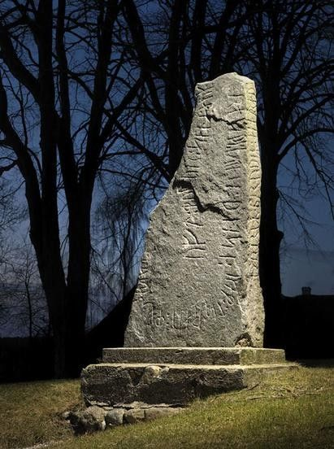

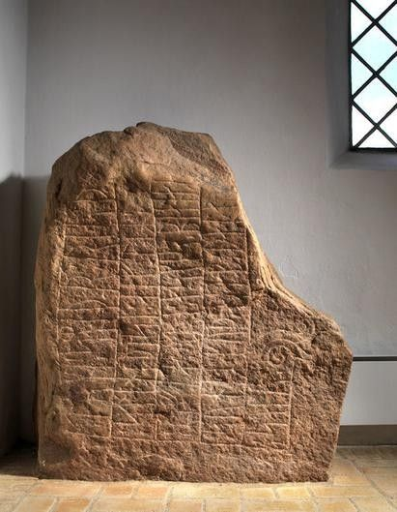

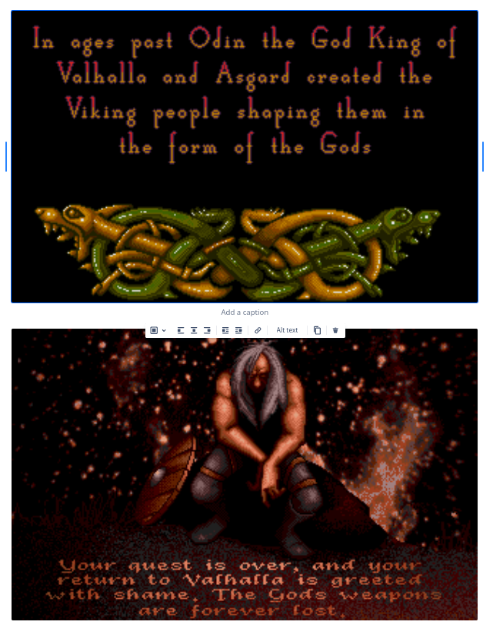

## Game won state

The player finishes a end game quest

The player have sacked all the NPC villages

A specific year is reached

unifiying sweden under your rule.

What makes this more fun and replayable?

Different paths to reach the end game quest

The NPC villages are randomly placed on the worldmap

There is some kind of highscore data that you can beat at a replay.

Random starting location

Different play styles playing as the different classes.

## Gameover state

What may cause a gameover state?

The main character dies in battle

The players village is sacked by the NPC

Render this to the screen

The second key belief of Norsemen is that the time of one's death is determined by fate and is chosen by the Norns at the time of one's birth. Therefore, nothing one did could change the moment of one's death. However, what one did up until that moment was strictly one's own doing. Therefore, one ought to make the very best of every moment of life, because the worst that could happen would be death, and the best that could happen would be fame and an enhancement to one's reputation. Since one couldn't effect the time of one's own death, which was predestined anyway, there was nothing to lose and everything to gain by being bold and adventurous.

Reset data

Reset the starting location of the actor.

Reset the actors hp.

Reset the enemies counter.

Reset spawned enemies in the raid map.

Reset rotation of the actor.

Return to the main menu

Reset the fog of war

## Professions( Classes )

Viking  
Marauder  
Shieldmaiden

## Names

Witolf

Willharm

Swarthead

Ymir

Here you can see some of the names that the Vikings used and what they meant.

### Male names from the Viking Age

Arne: eagle     
Birger: keeper      
Bjørn: bear      
Bo: the resident     
Erik: absolute ruler     
Frode: wise and clever    
Gorm: he who worships god   
Halfdan: the half Danish     
Harald: lord and ruler    
Knud: knot      
Kåre: with curly hair     
Leif: descendant   
Njal: giant      
Roar: fame and spear    
Rune: secret     
Sten: stone      
Skarde: with cleft chin    
Sune: son     
Svend: freeman who is in the service of another   
Troels: Thor’s arrow     
Toke: Thor and helmet     
Torsten: Thor and stone    
Trygve: trustworthy     
Ulf: wolf      
Ødger: wealth and spear    
Åge: man that ploughs; ancestor

### Female names from the Viking Age

Astrid: beautiful, loved  
Bodil: penance and fight  
Frida: peace  
Gertrud: spear  
Gro: to grow  
Estrid: god and beautiful   
Hilda: the fighter  
Gudrun: god and rune  
Gunhild: fight  
Helga: sacred  
Inga: of the god Inge  
Liv: of life  
Randi: shield or shrine  
Signe: the one who is victorious  
Sigrid: victorious horsewoman  
Revna: raven   
Sif: wife and bride  
Tora: of the god Thor   
Tove: dove  
Thyra: helpful  
Thurid: Thor and beautiful  
Yrsa: wild or she bear  
Ulfhild: wolf or battle   
Åse: goddess

## Locations

# Svartalfheimr

underground a place called Svartalfheim, which was thought to be a warren of mines and forges.

Where the Dökkálfar ("Dark Elves") lives

# Alfheimr

Where the Ljósálfar ("Light Elves") lives

# Ironwood

Then said Gangleri : " What is the race of the wolves ? “ Harr answered : " A witch dwells to the east of Midgard, in the forest called Ironwood : in that wood dwell the troll-women, who are known as Ironwood-Women. The old witch bears many giants for sons, and all in the shape of wolves ; and from this source are these wolves sprung. The saying runs thus : from this race shall come one that shall be mightiest of all, he that is named Moon-Hound; he shall be filled with the flesh of all those men that die, and he shall swallow the moon, and sprinkle with blood the heavens and all the air; thereof shall the sun lose her shining, and the winds in that day shall be unquiet and roar on every side. So it says in Foluspa:  
Eastward dwells the Old One in Ironwood, And there gives birth to Fenrir*s brethren; There shall spring of them all a certain one. The moon's taker in troll's likeness.  
He is filled with flesh of fey men.  
Reddens the gods' seats with ruddy blood-gouts;  
Swart becomes sunshine in summers after.  
The weather all shifty. Wit ye yet, or what?"

# Heaven

XIII. Then said Gangleri: '*What is the way to heaven from earth ? " Then Harr answered, and laughed aloud : "Now, that is not wisely asked; has it not been told thee, that the gods made a bridge from earth to heaven, called Bifrost? Thou must have seen it; it may be that ye call it 'rainbow.' It is of three colors, and very strong, and- made with cunning and with more magic art than other works of craftsmanship. But strong as it is, yet must it be broken, when the sons of Muspell shall go forth harrying and ride it, and swim their horses over great rivers ; thus they shall proceed." Then said Gangleri: "To my think- J P ing the gods did not build the bridge honestly, seeing that it could be broken, and they able to make it as they would." Then Harr replied : "The gods are not deserving of reproof because of this work of skill : a good bridge is Bifrost, but nothing in this world is of such nature that it may be relied on when the sons of Muspell go a-harrying."

## Inventory

Graphics

A grid of items of 9x10 squares on the right side of the screen and then there should be a character rendered in the middle with items slots for different item locations on the body.

Actions

* Drop
* Equip
* Drag & Drop

Todo

* Render character 
* Render item slots 
* Equip functionality 
* Drag & Drop functionality

Item slots

HEAD,NECK,SHOULDER,CHEST,LEFT_ARM,RIGHT_ARM,HANDS,LEGS,FEET

## Skillobjects

### Short blade

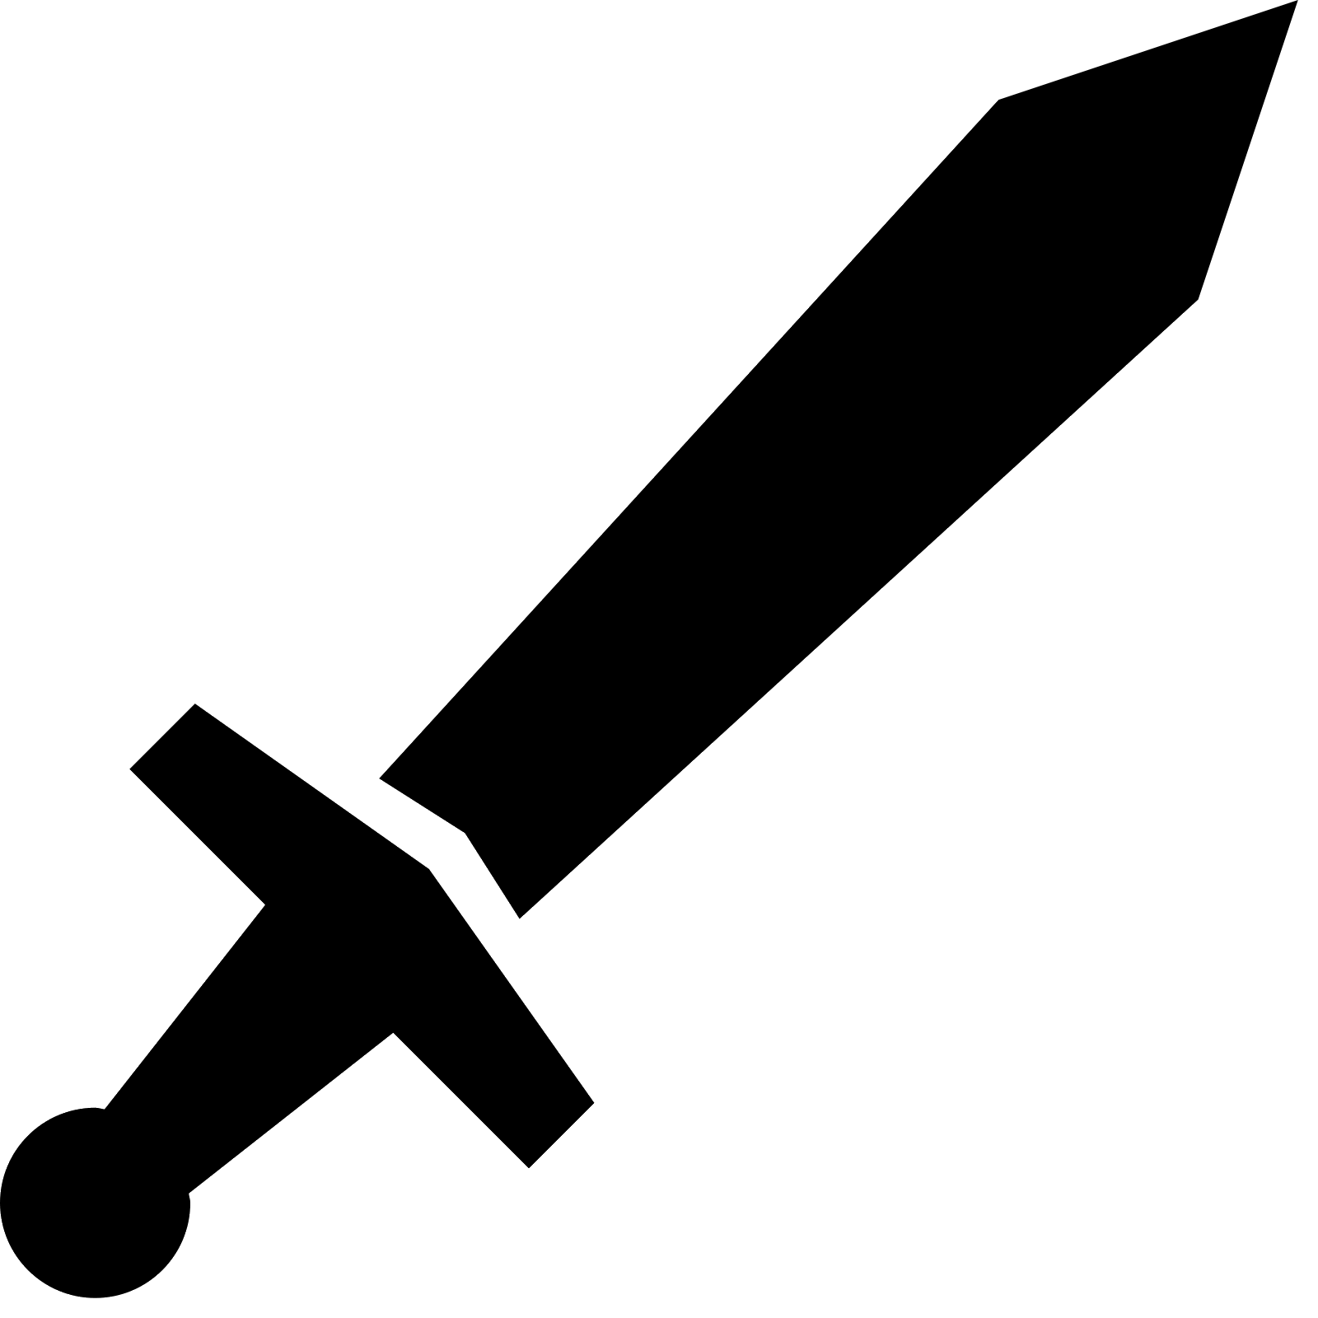Icon: Some kind of dagger like icon

Name: Shortblade

Group: Weapons

Learned: No

Maximum Expertise: 0

Initial Requirements Attribute: ???

Initial Requirements Value: 0

Group ID: 0

Description: A short blade weapon is a type of melee weapon that typically has a blade length of less than 18 inches. Short blade weapons can take many forms, including daggers, knives, and short swords. They are often used for close-quarters combat and can be wielded with one or two hands. Short blade weapons are known for their speed and agility, making them effective for quick strikes and defensive maneuvers. They can be made from a variety of materials, including metal, bone, and obsidian. The design of a short blade weapon can vary widely depending on its intended use and cultural context.

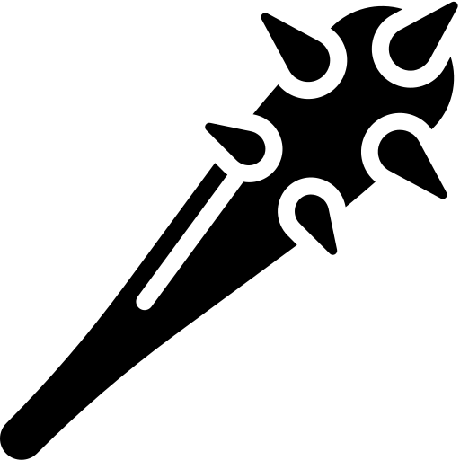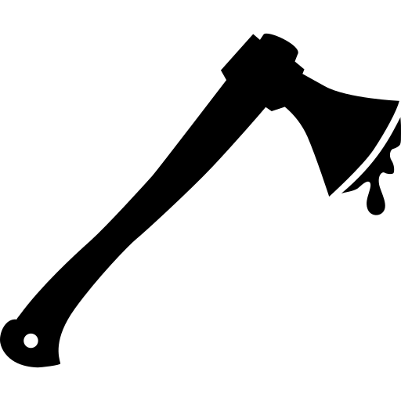

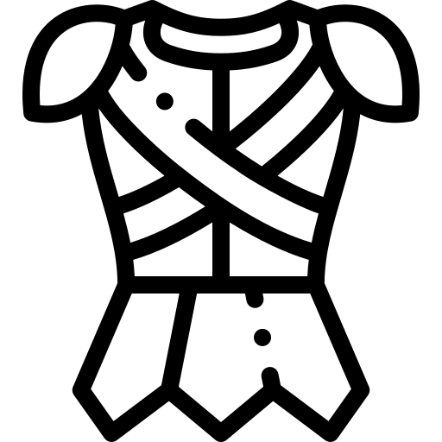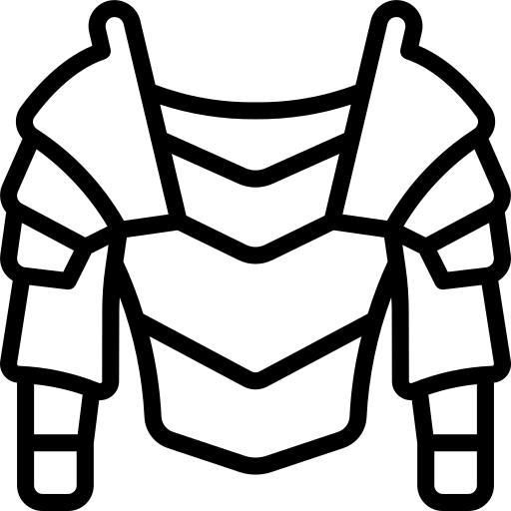

## Quest 1 - Rescue the Chieftain's Daughter

Objective: The Chieftain of the Viking village has asked you to rescue his daughter, who has been kidnapped by the powerful and feared sea-raider, Grim Thorvald.

Step 1: Gather Information: You must speak with the villagers in the Viking village to gather information about Grim Thorvald and his whereabouts. Some of the villagers may offer clues or rewards for your help.

Step 2: Acquire Supplies: You will need to equip yourself with weapons, armor, and provisions for your journey. Some of the villagers may offer to trade goods with you, or you can complete tasks for them in exchange for supplies.

Step 3: Sail to Grim Thorvald's Island: You must navigate the seas to reach Grim Thorvald's island, where he is holding the Chieftain's daughter captive. The journey will be treacherous, with dangerous creatures and storms to overcome.

Step 4: Infiltrate the Fortress: Once you reach the island, you must make your way to Grim Thorvald's fortress. You can choose to sneak in and avoid confrontation, or fight your way through his guards.

Step 5: Rescue the Chieftain's Daughter: Once you reach Grim Thorvald's throne room, you will face him in a final showdown. The Chieftain's daughter will be held captive nearby, and you must rescue her and defeat Grim Thorvald to complete the quest.

Rewards: If you successfully complete the quest, the Chieftain of the Viking village will reward you with riches, weapons, and the admiration of the villagers. You will also gain experience and reputation points, which can be used to upgrade your character and unlock new skills and abilities.

## Quest 2 - The Lost Relic of Odin

Background: The players are members of a Viking clan who have been tasked with finding a powerful artifact that was lost many years ago. The artifact is said to be the spear of Odin, the god of war and wisdom, and is believed to have the power to grant its wielder great strength and insight.

Objective: The players must travel to various locations throughout Scandinavia and beyond to gather clues about the location of the spear. Along the way, they will encounter challenges and obstacles that test their skills as warriors, navigators, and diplomats.

Tasks:

1. Visit a local seer or wise woman to learn more about the history of the spear and its possible whereabouts.
2. Travel by ship to a nearby island where it is rumored that one of Odin's followers may have hidden the spear.
3. Explore a dark cave system filled with traps and puzzles to find an ancient map that leads to another clue.
4. Negotiate with rival Viking clans who may also be searching for the spear.
5. Brave treacherous mountain passes and harsh weather conditions to reach a remote temple where Odin himself may have left clues about the spear's location.
6. Finally, engage in an epic battle against fierce enemies who are also seeking the spear.

Rewards: If successful in finding the lost relic of Odin, the players will gain great honor and respect within their clan, as well as powerful new abilities that can aid them in future quests. However, failure could mean disgrace or even death at the hands of their enemies.

## Quest 3 - The Raid on Lindisfarne

Background: The players are members of a Viking raiding party that has set its sights on the wealthy monastery of Lindisfarne, located on the coast of Northumbria in England. The Vikings hope to plunder the monastery's treasures and take captives to sell as slaves.

Objective: The players must plan and execute a successful raid on Lindisfarne, overcoming the defenses of the monastery and escaping with their loot and captives before reinforcements arrive.

Tasks:

1. Scout out the area around Lindisfarne to gather intelligence about the monastery's defenses and any potential obstacles.
2. Plan an attack strategy that takes into account the terrain, weather conditions, and number of defenders.
3. Launch a surprise attack on the monastery, using weapons like axes, swords, and spears to overcome any resistance.
4. Search for treasure within the monastery's walls while taking captives to be sold as slaves.
5. Escape from Lindisfarne before reinforcements arrive or other Viking raiders arrive to compete for loot.

Rewards: If successful in raiding Lindisfarne, the players will gain valuable treasure and captives that can be sold for profit back in Scandinavia. They will also earn great honor within their clan for their bravery in battle. However, failure could mean death or capture by English forces.

Note: This quest is based on historical events - in 793 AD, Vikings launched a surprise attack on Lindisfarne that is considered by many historians to mark the beginning of the Viking Age.

## Quest 4 - The Battle of Stamford Bridge

Background: The players are members of a Viking army led by King Harald Hardrada, who has invaded England in an attempt to claim the throne for himself. However, they have been intercepted by an English army led by King Harold Godwinson, who seeks to defend his kingdom from the Viking invaders.

Objective: The players must fight in the Battle of Stamford Bridge, one of the most significant battles of the Viking Age, and help their side emerge victorious.

Tasks:

1. Prepare for battle by gathering weapons and armor and strategizing with other members of the Viking army.
2. March towards Stamford Bridge while avoiding detection by English scouts.
3. Engage in fierce combat against English soldiers on the bridge itself, using weapons like swords, axes, and spears to overcome their defenses.
4. Push forward into enemy territory and engage in hand-to-hand combat with English soldiers on foot or horseback.
5. Help King Harald Hardrada achieve victory over King Harold Godwinson's forces.

Rewards: If successful in winning the Battle of Stamford Bridge, the players will gain great honor within their clan for their bravery in battle and may receive valuable treasure or land as a reward from King Harald Hardrada. However, failure could mean death or capture by English forces.

Note: The Battle of Stamford Bridge took place in 1066 AD and was fought between an invading Norwegian army led by King Harald Hardrada and an English army led by King Harold Godwinson. Although the Vikings initially achieved some success on the battlefield, they were ultimately defeated and forced to retreat back to Scandinavia.

## Other quests

1. Raid a nearby village to gather resources and loot.

2. Defend your village from an enemy attack.

3. Explore a nearby island to discover new resources and treasures.

4. Help a local chieftain settle a dispute with another tribe.

5. Rescue a kidnapped villager from an enemy stronghold.

6. Retrieve a stolen artifact from an enemy camp.

7. Escort a group of traders through dangerous territory to reach their destination.

8. Investigate reports of strange creatures or supernatural events in the area.

9. Participate in traditional Viking games and competitions to earn honor and prestige.

10. Build and upgrade your own longship to explore further and raid more effectively.

## World map

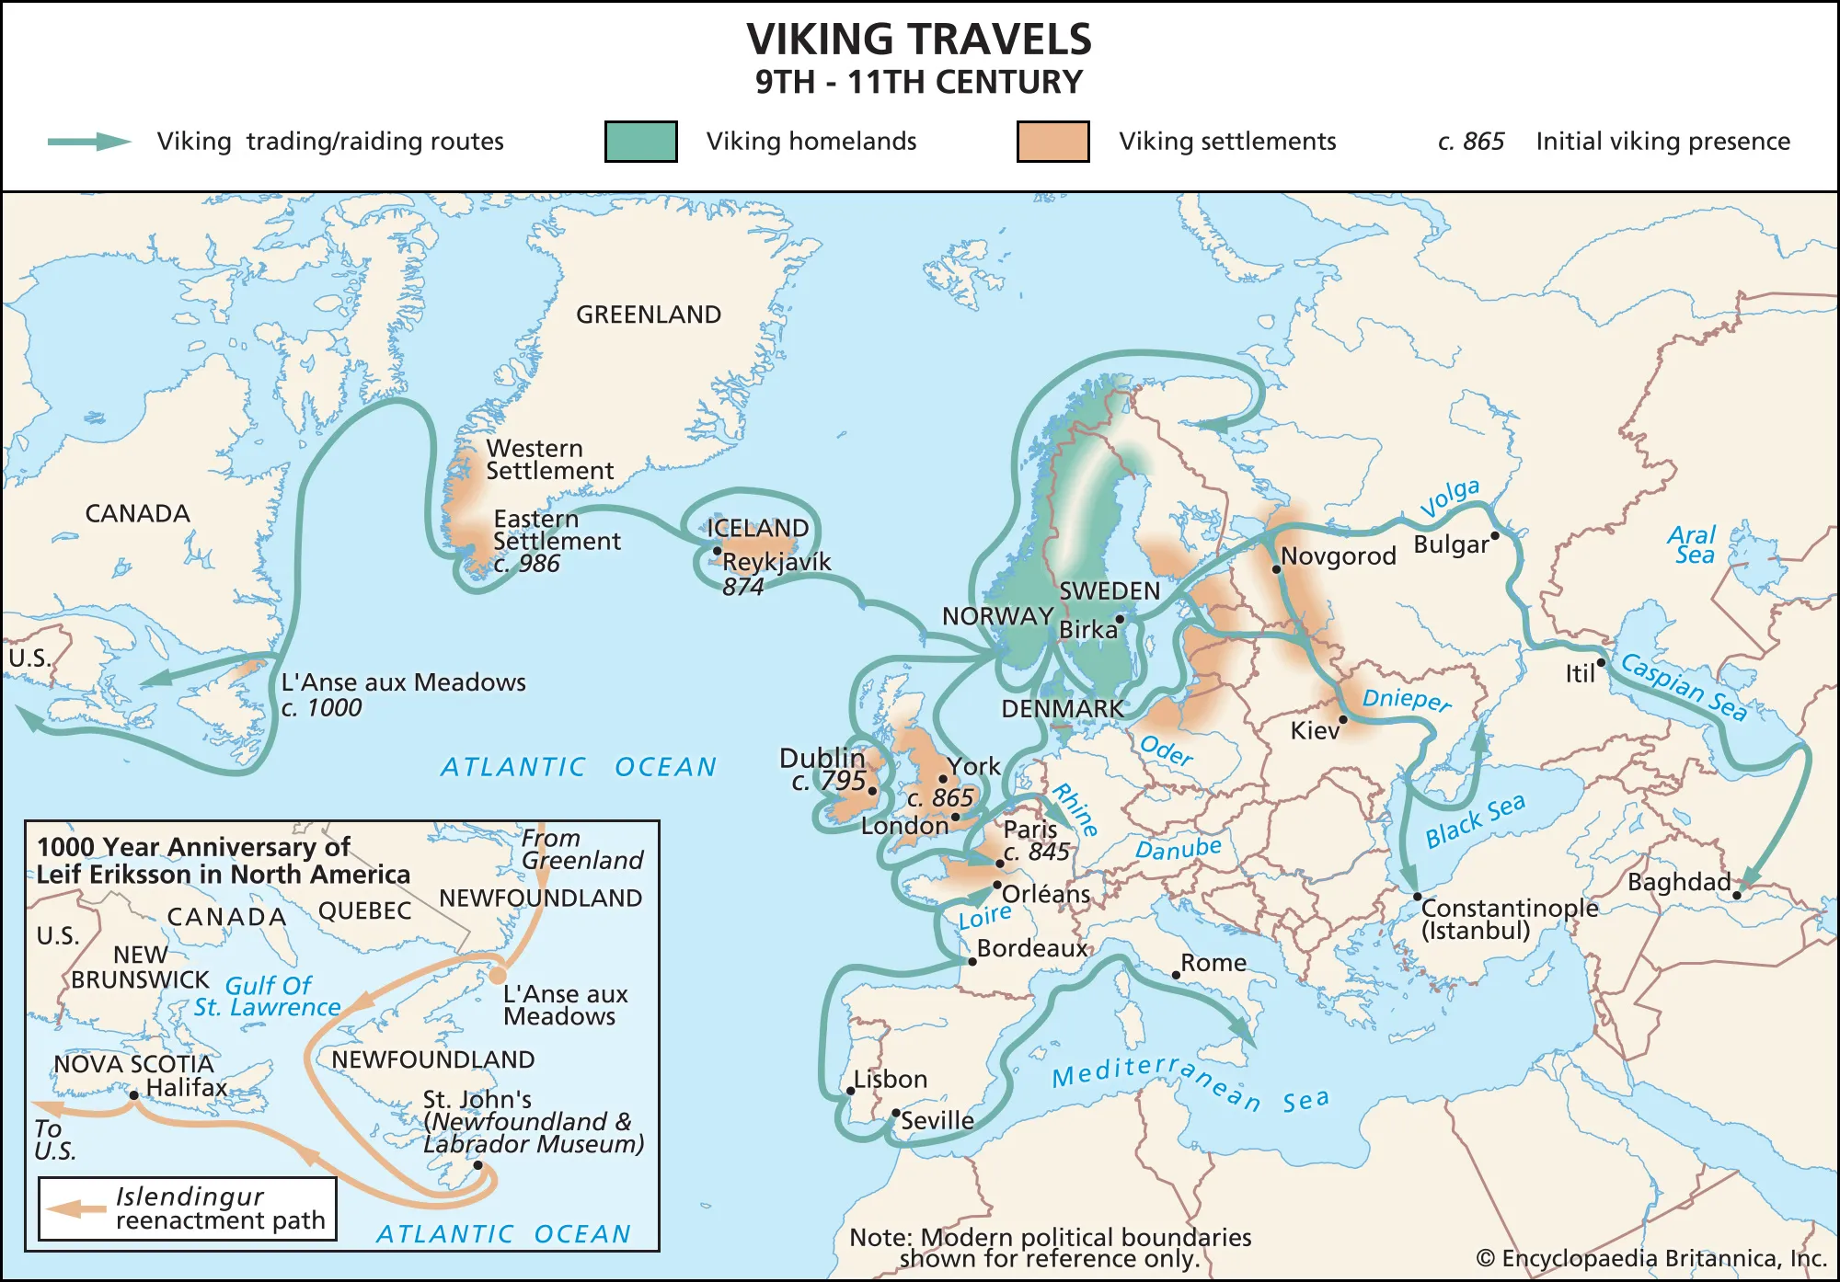

## Timeline and events

For example, the Danish king Sigfred’s brother, Halfdan, is said to have given Louis the German a sword with a gold hilt when he visited him on a diplomatic mission in 873. The missionary Ansgar also took fine gifts from King Louis when he set off to visit King Björn at Birka in 839. However, on the way these gifts were stolen by pirates, along with 40 books intended for use in Christian services.

## The bridge over Ravning Enge

At the same time as the great ring fortresses were constructed, a number of bridges at challenging locations were also built. The most impressive of these is the bridge over Ravning Enge in the valley of the River Vejle, 10 km south of Jelling. The bridge was constructed between 979 and 980. It is 760 m long and 5 m wide and its carrying capacity is estimated to have been five tons. Around 1200 heavy oak posts and 600 cross braces were used to make the bridge. 350 hectares of oak woods were felled to produce the timber. The bridge exemplifies the engineering skills that the Vikings possessed. Those in charge of the bridge’s construction must have undertaken geotechnical investigations before the building work began, as the bridge is located in the only possible place in the area. It displays few signs of wear, which suggests that it was reserved for the exclusive use of the king and his men. After a short period of use, the new bridges were allowed to fall into disrepair as early as the year 1000, after which they were succeeded by fords.

## Lejre – a royal seat

According to the Icelandic sagas and written sources from the medieval period, Lejre was supposed to have been the location where the first Danish royal family, the Scyldings, had their royal seat. However, these stories about the Scyldings should be regarded as fanciful myths and legends. Nevertheless, significant evidence now indicates that Lejre was in fact the headquarters of a royal family. Archaeological excavations have shown that Lejre has origins stretching back into the Iron Age, to the 6th century AD, and that it was already an important place at this time.

Furthermore, archaeologists have found a huge Viking settlement at Lejre, extending over an area of c. 125, 000 m2 and including a magnate’s residence. This consisted of a hall of royal dimensions - 48 m long and 11m wide. The hall is the largest known Viking building in Denmark. Official activities are likely to have taken place here.

A number of other buildings were also associated with the magnate’s residence – some up to 42 m long. The large houses are likely to have been for the magnate and his retinue, together with the guests who came to the visit him. These people may have been members of his family, his housecarls (soldiers) and magnates attending councils. The magnate’s residence and associated buildings were located on higher land, and were surrounded by a sturdy fence or palisade.  Outside this area were workshops and another small settlement.

At the end of the 900s much evidence suggests that the royal power base on Zealand was supplanted by the Jelling dynasty led by Harald Bluetooth. Harald took over the magnate’s residence at Lejre, only later to move his headquarters on Zealand to Roskilde. Changing political and personal circumstances meant that another location was soon preferred.

## Raiding party

Raiding party is the player army in the game and contains a number of different units depending on what the player have recruited.

## Battle Scene

This should be a separate scene where the battles in the game takes place bu to simplify things in the beginning of the development battles are only collision based on the world map.

## Settings Scene

This scene is a main menu subscene and should contain all the possible settings you can do for the game such as resolution, volume and more…

## Main menu Scene( Currently pause menu )

This should have all the main menu buttons for setting, play and load / save ...

## Load / Save Scene

This is more of a subscene for the main menu in the game and might be split into two scenes where one is load and the other is save depending on what feels best.

- Timestamped

- Delete

- Save / Load data to file

- Exit back to main menu

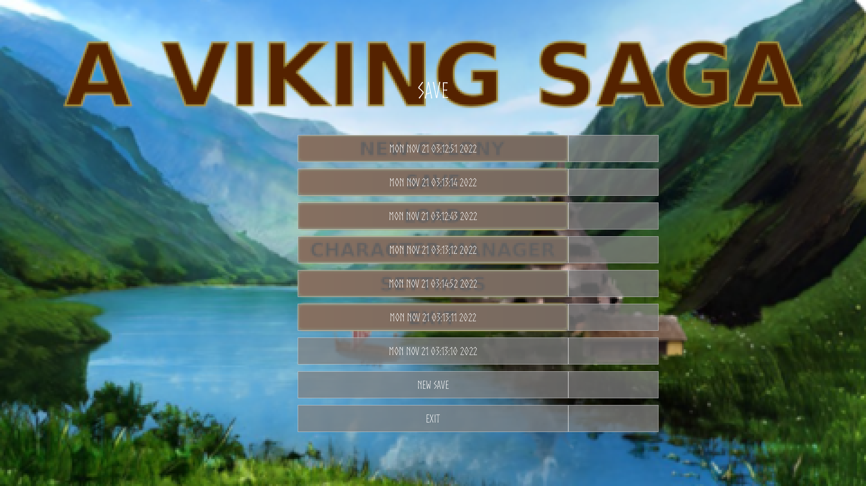

## Version goals

### Version 0.1

**Settlement**

### Version 0.2

**Settlement**

**Items**

Sword

Shield

Clothing

Armor

**Inventory**

Drag and drop between inventory and body slots

**Package**

Package and working release for linux and windows and publish

**Army**

Army size shown in the world view

### Version 0.3

### Version 0.4

### Version 0.5

### Version 0.6

### Version 0.7

### Version 0.8

### Version 0.9

### Version 1.0

## Diplomacy

There might be some kind of feature in the game for diplomacy between different factions

## Multiplayer

There might in the future be some kind of mutiplayer for the game.

## Technology tree

There might be some kind of tech tree implemented but nothing planned for now.

## Random events

When sailing or moving around on the world map and even in settlements there might be some kind of random events happening that the player needs to act upon or ignore.

## Hero units

Should the raiding party have some kind of hero units???

## Fog of war

The world map should have some kind of fog of war implemented to make it more fun to discover the world and let the player know where they have been and not been.

## Units training

Shoudl there be some kind of improment for the units in the raiding party or not??

## Settlement building

Should the player settlement be static with everything in or should the player be able to improve upon the settlement like for instance building barracks to recruit better units or something long that line.

## Resource management

The player will need different resources to build ships and builds in the settlement and also food and water for the people.

## Ships

There should be a couple of different ships available to the player that can carry diffferent amount of warriors and cargo.

## Old norse translator

This will most likely be some kind of tool for the developers to translate text into old norse from english, might be a game setting to play with only the old norse text or english depending on the immersion you want.

Here are the four cardinal directions and four ordinal directions in Old Norse:

1. North - norðr

2. East - austr

3. South - suðr

4. West - vestr

5. Northeast - norðaustur

6. Southeast - suðaustur

7. Southwest - suðvestur

8. Northwest - norðvestur

The Old Norse language used a runic alphabet called the Younger Futhark, which consisted of 16 letters. Here are the names and transliterations of each letter:

1. ᚠ - fé ("f")

2. ᚢ - úr ("u")

3. ᚦ - þorn ("th")

4. ᚬ - áss ("a")

5. ᚱ - reið ("r")

6. ᚴ - kaun ("k")

7. ᚼ - hagall ("h")

8. ᚾ - nauðr ("n")

9. ᛁ - ís ("i")

10.ᛅ - ár ("a" or "aa")

11.ᛋ - sól ("s")

12.ᛏ - Týr ("t")

13.ᛒ - bjarkan ("b")

14.ᛘ - maðr ("m")

15.ᛦ - yr ("y" or "ü" or "ö", depending on dialect)

16.ᛒᛦ (ligature) – eiwaz/īor (either "ei" or "j")

Note that some of these letters have different pronunciations depending on the dialect and time period, and some letters may be represented by multiple runes in certain contexts (such as the letter "g", which can be written as either "kaun" or "gyfu").

## Cyberpunk twist to the story

In a world where the Viking age and cyberpunk technology collide, a child is born into a small Viking village. His name is Erik, and from a young age, he is fascinated by the ancient Viking culture that surrounds him.

As he grows older, Erik becomes more and more interested in the stories of his ancestors, the fierce warriors who sailed the seas and conquered new lands. He spends hours listening to the tales of his elders, dreaming of one day becoming a great Viking warrior himself.

But Erik is also fascinated by the high-tech gadgets and weapons that he sees in the world around him. He spends his free time tinkering with machines and building his own gadgets, always pushing the limits of what is possible.

As he reaches adulthood, Erik becomes a respected member of his village, known for his skill with both traditional Viking weapons and high-tech gadgets. He is often called upon to lead raids against rival Viking clans, using his knowledge of technology to gain the upper hand.

But despite his success as a warrior, Erik never forgets his love of technology. He spends his free time experimenting with new gadgets and weapons, always looking for ways to improve upon the designs of his ancestors.

As the years go by, Erik becomes a legend in his own time, a fierce warrior and brilliant inventor who embodies the best of both the ancient and modern worlds. And though he may never know what the future holds, he knows that he will always be a proud cyberpunk Viking, fighting for his people and pushing the limits of what is possible

In a distant future, humanity has reached the pinnacle of technological advancement, but at a great cost. The world has become a harsh and unforgiving place, with most of the population living in sprawling, high-tech cities ruled by powerful corporations.

But in the midst of this bleak world, a group of rebels emerges, determined to reclaim the ancient ways of their Viking ancestors. They reject the sterile, artificial world of the cities and instead embrace the rugged, independent spirit of the Viking age.

These cyberpunk Vikings combine the best of ancient and modern technology, using high-tech gadgets and weapons to enhance their traditional Viking skills. They sail the seas in sleek, high-tech ships, raiding the cities and corporations that they see as their enemies.

At the heart of this movement is a group of brilliant inventors and engineers, who use their knowledge of technology to create new weapons and gadgets that give the cyberpunk Vikings an edge in battle. They are led by a charismatic warrior who embodies the best of both the ancient and modern worlds, inspiring his followers to fight for their freedom and independence.

As the cyberpunk Viking movement grows, it attracts more and more followers, both from the cities and from other Viking clans. They form a loose confederation of rebels, united by their love of freedom and their rejection of the sterile, artificial world of the cities.

And though they face many challenges and obstacles, the cyberpunk Vikings remain steadfast in their determination to reclaim the ancient ways of their Viking ancestors, and to forge a new path forward in a world that has lost its way.

create a cyberpunk viking story of a child growing up in that world  
In a world where ancient Viking culture and futuristic technology collide, a child is born into a cyberpunk Viking village. Her name is Freya, and from a young age, she is fascinated by the high-tech gadgets and weapons that her village produces.

As she grows older, Freya becomes more and more interested in the technology that surrounds her. She spends hours tinkering with machines and building her own gadgets, always pushing the limits of what is possible.

But Freya is also a fierce warrior, trained in the traditional Viking ways of combat. She spends long hours practicing with her sword and shield, honing her skills and preparing for battle.

As she reaches adulthood, Freya becomes a respected member of her village, known for her skill with both technology and weapons. She is often called upon to lead raids against rival Viking clans, using her high-tech weapons and armor to gain the upper hand.

But despite her success as a warrior, Freya never forgets her love of technology. She spends her free time experimenting with new gadgets and weapons, always looking for ways to improve upon the designs of her ancestors.

As the years go by, Freya becomes a legend in her own time, a fierce warrior and brilliant inventor who embodies the best of both the ancient and modern worlds. And though she may never know what the future holds, she knows that she will always be a proud cyberpunk Viking, fighting for her people and pushing the limits of what is possible.

A cyberpunk Viking village would be a fusion of ancient Viking architecture and futuristic technology. The buildings would be made of traditional materials like wood and stone, but with high-tech additions like neon lights, holographic displays, and energy shields.

The village would be surrounded by a high-tech force field that protects it from the harsh elements of the Viking world, as well as from hostile invaders. The force field would be powered by a combination of traditional Viking energy sources like wind and water, as well as advanced energy systems like fusion reactors and solar panels.

The villagers themselves would be a mix of traditional Viking warriors and high-tech specialists like engineers, hackers, and cyberneticists. They would wear a mix of traditional Viking clothing and high-tech armor, with built-in sensors, energy shields, and weapons systems.

The village would have a central marketplace where villagers could trade goods and services, both traditional and high-tech. There would also be a central hall where the village leaders could meet to discuss important matters and make decisions.

In terms of transportation, the villagers would have access to a mix of traditional Viking ships and high-tech hovercraft and airships. They would also have access to advanced communication systems like holographic displays and neural implants.

Overall, a cyberpunk Viking village would be a unique and fascinating blend of ancient and modern technology, with a fierce and independent spirit that embodies the best of both worlds.

## Game pitch

The following is Vanderbulls proposal for a viking themed game.

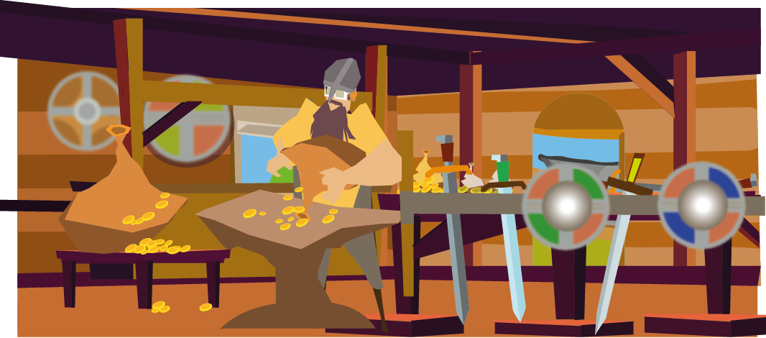Title: The Last Viking

Logline: When a young Viking warrior is the sole survivor of a brutal raid on his village, he must embark on a perilous journey to seek revenge and restore honor to his people.

Synopsis: Ragnar is a young Viking warrior who dreams of becoming a legendary hero like his father. But when his village is attacked by a rival clan, Ragnar is the only survivor. Fueled by rage and grief, he sets out on a quest for vengeance.

As he travels across the harsh Nordic landscape, Ragnar faces many challenges and dangers. He battles fierce beasts, navigates treacherous terrain, and confronts hostile tribes. Along the way, he meets other survivors of the raid who join him in his quest.

But as Ragnar gets closer to his goal, he begins to question whether revenge is worth sacrificing everything else. He learns that honor and glory are not just won through violence, but also through compassion and sacrifice.

In the end, Ragnar must make a choice that will determine not only his own fate but also the fate of his people. Will he continue down the path of vengeance or find another way to restore honor to his fallen comrades?

Target audience: This story would appeal to fans of historical fiction, action-adventure stories, and epic tales of heroism. It could be marketed towards both young adult and adult audiences. Themes: Revenge, honor, sacrifice, redemption

<https://www.graybeardgames.com/download/diablo_pitch.pd>